Power BI - Complete Detailed Guide

📚 TABLE OF CONTENTS
- Business Intelligence (BI)
- Power BI - Complete Overview
- Power BI Architecture & Data Processing Pipeline
- Power BI Components - Detailed Analysis
- Power BI Tools - Complete Guide
- Dashboards vs Reports - Comparative Analysis
- Power BI Data Sources - Comprehensive List
- Power BI Gateway - Technical Architecture
- Power BI DAX - Complete Reference
- Practical Examples & Use Cases
- Best Practices & Tips

1. Business Intelligence (BI)
What is Business Intelligence?
Business Intelligence (BI) is a technology-driven process for analyzing data and presenting actionable information to help corporate executives, business managers, and other end users make more informed business decisions.
Detailed Definition
BI encompasses the strategies and technologies used by enterprises for data analysis of business information. It provides historical, current, and predictive views of business operations.
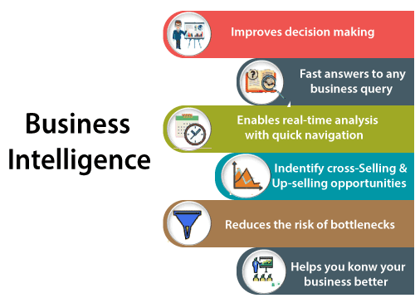

- Key Components of BI
BI COMPONENTS
- 📊 Data Warehousing → Storing structured data
- 🔍 Data Mining → Finding patterns in data
- 📈 Reporting → Creating standard reports
- 📉 Performance Metrics → KPIs and benchmarks
- 📊 Descriptive Analytics→ What happened?
- 🔮 Predictive Analytics → What will happen?
- 📋 Prescriptive Analytics→ What should we do?
- 📱 Dashboarding → Visual data presentation

- BI vs Traditional Reporting
Aspect | Traditional Reporting | Business Intelligence
Time | Historical data only | Real-time & historical
Format | Static, printed reports | Interactive, dynamic
Users | IT specialists | All business users
Insight | What happened | Why it happened
Access | Limited to few | Self-service for all
Analysis | Descriptive | Predictive & prescriptive

- Evolutionary History of Power BI
Power BI originated from Microsoft's SQL Server Reporting Services (SSRS) team, conceptualized by Thierry D'Hers and Amir Netz:
- 2010 (Project Crescent): Designed by West Chadic George under the codename Project Crescent.
- 2011 (Mount McKinley): Tied up with SQL Server codenamed Mount McKinley.
- September 2014: Microsoft unveiled the public preview of standalone Power BI.
- July 24, 2015: General availability of Power BI, initial versions leveraging Excel add-ins (Power Query, Power Pivot, Power View).

2. Power BI - Complete Overview
What is Power BI?
Power BI is a suite of business analytics tools that deliver insights throughout your organization. It connects to hundreds of data sources, simplifies data prep, and drives ad hoc analysis.
Power BI Editions
- 🆓 FREE
  - Power BI Desktop (unlimited)
  - Power BI Service (1 GB/user storage)
  - 8 scheduled refreshes/day
  - Unlimited visualizations
- 💼 PRO ($10/user/month)
  - All Free features
  - 10 GB/user storage
  - 48 scheduled refreshes/day
  - Share and collaborate
  - Apps and content packs

- 🏢 PREMIUM (Custom pricing)
  - All Pro features
  - 100 TB storage capacity
  - Unlimited refresh
  - Paginated reports
  - On-premises deployment
  - AI capabilities
Power BI Workflow
POWER BI WORKFLOW
1️⃣ CONNECT : The workflow begins in Power BI Desktop by establishing connections to your raw data sources
Connect to data sources (Excel, SQL, Cloud, etc.)
↓
2️⃣ TRANSFORM : Once connected, raw data is rarely ready for reporting. Opening the Power Query Editor allows you to clean, reshape, and structure the data before loading it
Clean( Removing duplicate rows) , Handling missing values , Standardizing column data types ,shape, and prepare data using Power Query
↓
3️⃣ MODEL : After loading clean data, you transition to the Model View to define how tables relate to one another , Add slicers, cross-filtering, tooltips, drill-through pages
Create relationships, calculations, and measures
↓
4️⃣ VISUALIZE : Design Interactive Reports (Visual Canvas)
In the Report View, report authors build the visual presentation layer
Create charts, graphs, and reports
↓
5️⃣ SHARE : When the .pbix report file is complete, it is published from Power BI Desktop to the cloud-based Power BI Service (or on-premises Power BI Report Server)
Publish reports and dashboards to Power BI Service
↓
6️⃣ COLLABORATE
Share insights and work together
Benefits ( Advantages) of BI in Detail
- 💰 Driving New Revenues
  - Identify cross-selling opportunities
  - Discover new market segments
  - Optimize pricing strategies

- ⚡ Increasing Operational Efficiency
  - Streamline business processes
  - Reduce costs through insights
  - Optimize resource allocation

- 🎯 Optimizing Internal Business Processes
  - Identify bottlenecks
  - Improve workflow efficiency
  - Enhance quality control

- 🧠 Improving Decision Making
  - Data-driven decisions
  - Faster decision making
  - Reduced risk

- 🏆 Competitive Advantage
  - Market trend identification
  - Customer behavior insights
  - Strategic planning
- Secure Report Publishing: You can automate setup data refresh and publish reports that allowing all the users to avail the latest information.
- No Memory and Speed Constraints: To Shift an existing BI system into a powerful cloud environment with Power BI embedded eliminates memory. Speed constraints ensure that data is quickly retrievable and analyzed.
- No Specialized Technical Support required: The Power BI provides quick inquiry and analysis without the need for specialized technical support. It also supports a powerful natural language interface and the use of intuitive graphical designer tools.
- Simple to Use: Power BI is simple to use. Users can easily find it only on behalf of a short learning curve.
- Constant innovation: The Power BI product is updated in every month with new functions and features.
- Rich, personalized dashboard: The crowning feature of Power BI is the information dashboards that can be customized to meet the exact need of any enterprise. You can easily embed the dashboards, and BI reports in the applications to provide a unified user experience.
OR
Detailed Breakdown of Business Benefits:
1. Data-Driven Strategic Decision Making: Eliminates reliance on 'gut feeling' by establishing a Single Source of Truth (SSOT). Organizations align operational decisions (e.g., regional inventory allocation) directly with quantitative statistical indicators.
2. Fast Automated Querying & Reporting: Replaces manual SQL script writing and static Excel updates with automated ETL pipelines. Reduces report generation cycles from days or weeks to automated, instant visual updates.
3. Real-Time Operational Monitoring: Integrates streaming data feeds (e.g., Azure Stream Analytics, IoT sensor streams) into live dashboards, allowing instant identification of operational bottlenecks, network downtimes, or financial fraud.
4. Advanced Cross-Selling & Customer Retention: Utilizes historical transactional basket analysis to identify customer buying patterns. Businesses can trigger targeted marketing campaigns and automated product recommendations based on spending clusters.
5. Process Optimization & Bottleneck Reduction: Monitors Key Performance Indicators (KPIs) across supply chains and production lines, exposing friction points, late delivery vendors, and non-performing business units.
Self-Service Business Intelligence (SSBI):
Traditional BI required IT departments to write SQL queries, design database schemas, and render static PDF reports. Self-Service Business Intelligence (SSBI) shifts the reporting capability directly to business analysts and non-technical stakeholders. Through drag-and-drop interfaces, automated data transformations, and natural language interfaces, analysts import, model, and visualize data independently without waiting for IT intervention.
💡 ENTERPRISE BI IN PRACTICE
Real-World Scenario: A global logistics provider processes 200,000 package shipments daily across 5 continents. By deploying BI dashboards connected directly to vehicle GPS feeds and weather APIs, dispatchers track transit delays in real-time, reroute drivers automatically around storm paths, and reduce annual fuel consumption by 14%.

Disadvantages of Power BI
Here are some disadvantages of Power BI, as shown below:
- Dashboards and reports are only shared with the users who are having the same email domains.
- Power BI will not merge imported data that is accessed from real-time connections.
- Power BI only accepts the file size maximum 250 Mb and the zip file which is compressed by the data of the x-velocity in-memory database.
- Dashboard never accepts or pass user, account, or any other entity parameters.
- Very few data sources permit real-time connections to Power BI reports and dashboards.
Real-World BI Example
Company: Amazon
- Problem: Understanding customer buying patterns
- BI Solution: Analyze purchase history, browsing behavior, and demographics
- Result: Personalized recommendations, increased sales by 35%

Why Power BI? - Comparison with Other Tools
Feature | Power BI | Tableau | QlikView
Cost | Low | High | High
Learning Curve | Easy | Moderate | Steep
Data Sources | 100+ | 75+ | 50+
Cloud Integration | Excellent | Good | Moderate
Mobile Support | Excellent | Good | Moderate
Natural Language | Yes | Limited | No
Microsoft Integration | Perfect | Good | Limited

Power BI Architecture & Data Processing Pipeline
POWER BI ARCHITECTURE ─────────────────────────────────────────────────────────────────────────────

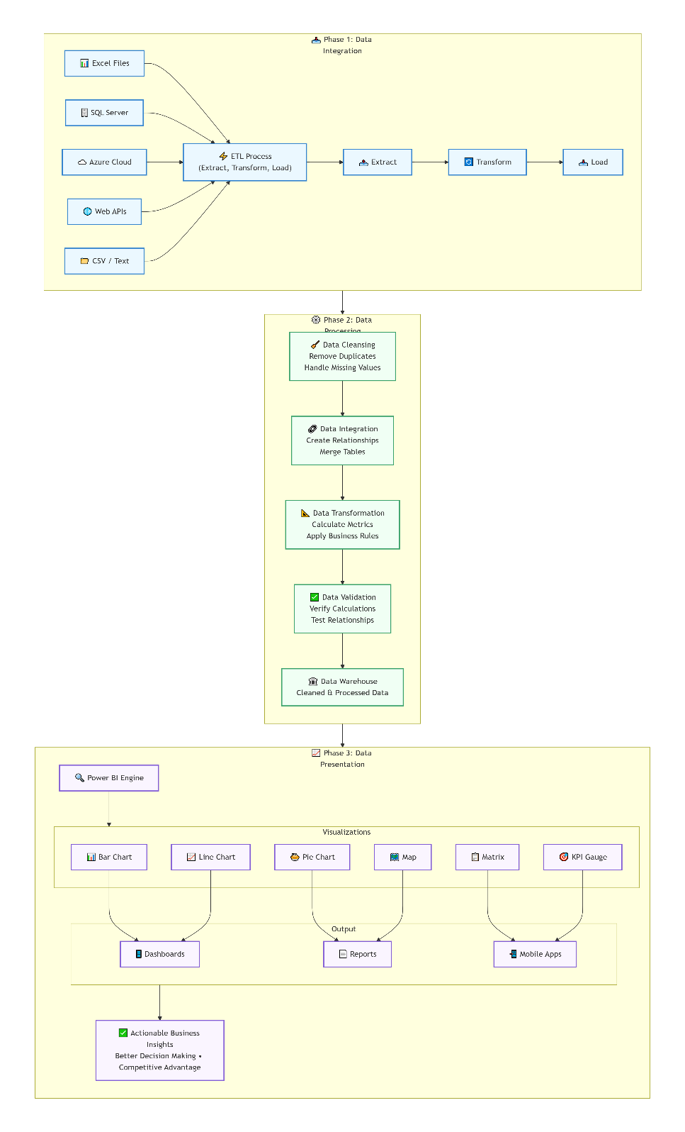
Architecture Phases & Data Processing Pipeline

Phase 1: Data Integration
Purpose: Extract data from various sources and prepare it for processing or in other words Extracts raw, structured, or unstructured data from diverse locations (SQL, SAP, Oracle, Excel, Web, Cloud APIs) into a unified staging area
Phase 1 : DATA INTEGRATION PROCESS
- EXTRACT
  - Source Identification
  - Connection Establishment
  - Data Extraction
  - Initial Load
- TRANSFORM
  - Data Validation
  - Format Conversion
  - Data Enrichment
  - Data Aggregation
- LOAD
  - Staging Area Storage
  - Indexing
  - Data Quality Checks
Real-World Example:
- Source: Sales data from CRM, Financial data from ERP, Customer data from Excel
- Extract: Pull all data using Power Query
- Transform: Convert date formats, standardize currency, combine tables
- Load: Store in staging area for processing

Phase 2: Data Processing
Purpose: Clean, validate, and prepare data for analysis or Power Query cleans raw data by handling missing values, removing duplicates, enforcing data types, and applying business rules before loading structured data into the internal data model (Data Warehouse / VertiPaq Engine).
Phase 2 : DATA PROCESSING STEPS
1. DATA CLEANSING
- Remove duplicates
- Handle missing values (mean, median, custom)
- Remove outliers
- Correct data types
2. DATA INTEGRATION
- Join tables
- Merge datasets
- Create relationships
3. DATA TRANSFORMATION
- Calculate new metrics
- Create hierarchies
- Apply business rules
- Aggregate data
4. DATA VALIDATION
- Check data completeness
- Verify calculations
- Test relationships
- Validate against source

Phase 3: Data Presentation
Purpose: Visualize data and create insights or End users consume rich, interactive visual reports and dashboards hosted in Power BI Service or Report Server, enabling data-driven organizational decision-making
Phase 3: Data Presentation FEATURES
📊 VISUALIZATIONS
- Bar charts (vertical & horizontal)
- Line charts (trends over time)
- Pie charts (proportions)
- Scatter plots (correlations)
- Maps (geographic data)
- Matrices (tabular data)
- Gauge charts (KPIs)
- Custom visuals
🎯 INTERACTIVITY
- Filters (page, visual, report)
- Slicers (data selection)
- Drill-down (detailed views)
- Drill-through (related reports)
- Bookmarks (saved views)
- Tooltips (additional info)
🤖 AI FEATURES
- Q&A (natural language queries)
- Quick Insights (automatic analysis)
- Decomposition Tree (root cause analysis)
- Key Influencers (factor analysis)

4. Power BI Components - Detailed Analysis
Core Components & Ecosystem Tools ( in Brief)
Power BI relies on a rich ecosystem of modular components designed for distinct stages of the business intelligence lifecycle.
Component / Tool | Primary Function & Usage
Power Query | ETL Engine used to extract, transform, clean, and reshape raw data sources.
Power Pivot | In-memory Data Modeling engine enabling advanced DAX measures and relationships.
Power BI Desktop | Free Windows-based desktop authoring application for reports and data models.
Power BI Service | Cloud-based SaaS platform for publishing, sharing, collaborating, and workspace management.
Power BI Gateway | Secure bridge connecting cloud services to on-premises data sources.
Power BI Report Server | On-premises report hosting environment managed within enterprise IT infrastructure.

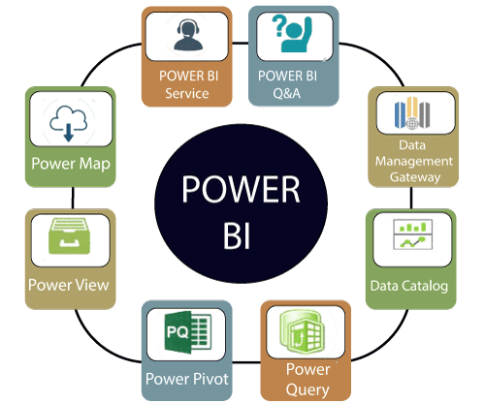

Component 1: Power Query
What is Power Query?
Component 1) Power Query (The ETL Engine)
- Primary Purpose: Handles Extract, Transform, and Load (ETL) operations. It serves as the data transformation layer across Power BI Desktop, Excel, and Power BI Dataflows.
- How It Works:
  - Data Connectors: Connects natively to hundreds of data sources (SQL, SAP, Web APIs, Excel, Azure Data Lake).
  - Transformation Pipeline: Applies non-destructive cleaning steps—unpivoting columns, standardizing types, parsing JSON/XML, filtering rows, and replacing null values.
  - Enterprise Usage Scenario: A retailer receives daily sales files from 10 different regional stores with varying date formats and redundant rows. Power Query standardizes column headers, strips out duplicate order IDs, converts local currencies to USD, and appends all 10 files into a single unified table

Component 2) Power Pivot
What is Power Pivot?
2. Power Pivot (Data Modeling & DAX Engine)
- Primary Purpose: Functions as the in-memory Data Modeling and Analytics Engine.
- How It Works:
  - Star Schema Engine: Connects separate Fact tables to Dimension tables via $1:*$ relationships.
  - VertiPaq Engine: Uses columnar in-memory storage, applying Hash Encoding, Value Encoding, and Run-Length Encoding (RLE) to compress data by up to 10x–20x.
  - DAX Computation: Evaluates Data Analysis Expressions (DAX) dynamically to generate custom measures, KPIs, calculated columns, and time intelligence logic
  - Enterprise Usage Scenario: A financial analyst connects an 80-million-row Sales fact table to Customer and Date dimension tables. Power Pivot compresses the dataset down to 1.5 GB in RAM and evaluates real-time Year-over-Year (YoY) revenue growth across millions of rows in milliseconds
📊 DATA MODELING
- Table creation
- Relationships (one-to-one, one-to-many, many-to-many)
- Hierarchies
- Calculated columns
- Measures

🧮 CALCULATIONS
- DAX formulas
- Calculated tables
- Time intelligence
- KPIs

⚡ PERFORMANCE FEATURES
- In-memory engine (xVelocity)
- Compression
- VertiPaq engine
- Query optimization

Component 3) What is Power View?
Power View is a data visualization tool that creates interactive charts, graphs, maps, and other visuals.
Visualization Types
📊 CHARTS
- Bar Chart (Stacked, Clustered, 100%)
- Column Chart
- Line Chart
- Area Chart
- Pie Chart
- Donut Chart
- Scatter Chart
- Bubble Chart
- Waterfall Chart
- Funnel Chart
Combo Chart (Line + Column)

🗺️ MAPS
- Map (Bing Maps)
- Filled Map (Choropleth)
- Shape Map
- ArcGIS Maps

📈 OTHER VISUALS
- Matrix
- Table
- Gauge
- Card
- KPI
- Slicer
- Filter

When to Use Which Visualization
Visualization | Use Case | Example
Bar Chart | Compare categories | Sales by product
Line Chart | Show trends over time | Monthly revenue
Pie Chart | Show proportions | Market share
Scatter Plot | Show relationships | Price vs demand
Map | Geographic data | Sales by region
Gauge | Show progress vs target | Achievement %
Matrix | Tabular with aggregations | Sales by region & product
Funnel | Show stage-wise drop-off | Sales pipeline

Component 4) Power BI Desktop (Authoring Application)
- Primary Purpose: A free local Windows application used as the primary development environment for report authors and analytics engineers.
- How It Works:
  - Combines Power Query, Power Pivot, and a canvas into a single workspace saved as a .PBIX file.
  - Provides 30+ core visual types (bar charts, matrix grids, decomposition trees, map visualizers) along with custom visuals.
  - Enterprise Usage Scenario: A BI developer builds a dataset, configures static/dynamic RLS security roles for regional sales teams, formats the interactive report canvas, and publishes the file to Power BI Service
🔌 DATA CONNECTION
- Connect to 100+ data sources
- Get Data from files, databases, cloud
- Import or DirectQuery modes
- Live connections

🔧 DATA TRANSFORMATION
- Power Query Editor
- 300+ transformation functions
- M language support
- Query folding optimization

📊 DATA MODELING
- Create relationships
- Manage hierarchies
- Create calculated columns
- DAX formulas
- Measures
- KPIs

📈 REPORT BUILDING
- Drag and drop interface
- 100+ visual types
- Custom visuals
- Bookmarks
- Drill-through
- Report themes

🚀 PUBLISHING
- Publish to Power BI Service
- Publish to Report Server
- Share with others
- Export options

Component 5) Power BI Service (Cloud SaaS Platform)
- Primary Purpose: The cloud-based Software as a Service platform used to publish, distribute, automate, and govern reports across an organization.
- How It Works:
  - Dashboards: Pins individual visual tiles from multiple reports onto a single operational dashboard.
  - Automated Refresh: Orchestrates scheduled background data refreshes (up to 48 times daily on Premium capacity)
  - Enterprise Usage Scenario: An executive team consumes a daily sales dashboard. Power BI Service automatically refreshes the dataset at 6:00 AM, sends automated email alerts if revenue drops below threshold, and restricts access using Microsoft Entra ID (Azure AD) permissions
POWER BI SERVICE FEATURES
📤 PUBLISHING & SHARING
- Publish reports from Desktop
- Share dashboards with users
- Create workspaces for collaboration
- Control access with permissions
- Share with external users (Pro)

🔄 DATA REFRESH
- Schedule automatic refresh
- Refresh on demand
- 8-48 refreshes/day (edition dependent)
- Incremental refresh
- Data gateway support

🤖 AI CAPABILITIES
- Quick Insights
- Q&A natural language
- Decomposition Tree
- Key Influencers
- Automatic ML models (Premium)

📱 MOBILE ACCESS
- iOS app
- Android app
- Windows app
- Annotate & share
- Offline viewing

🔒 SECURITY & GOVERNANCE
- Row-level security
- Data classification
- Audit logs
- Sensitivity labels
- Microsoft Information Protection

🛠️ ADMINISTRATION
- Usage metrics
- Capacity management
- API access
- Custom branding

Component 6) Power BI On-Premises Data Gateway
- Primary Purpose: A secure proxy bridge connecting cloud-based Power BI Service to internal, on-premises data sources located behind corporate firewalls.
- How It Works:
  - Acts as an outbound encrypted communications tunnel leveraging Azure Service Bus.
  - Enables cloud datasets to execute DirectQuery or Import Refresh against local SQL databases, Oracle instances, or network shares without opening inbound firewall ports..
  - Enterprise Usage Scenario: A report hosted in the public Microsoft Cloud needs to show live inventory levels from an internal, firewalled SQL Server database. The Gateway intercepts the user's report query, fetches the local SQL data, encrypts it, and renders the result in the cloud browser without data exposure

Component 7) Power BI Report Server (On-Premises Architecture)
- Primary Purpose: An on-premises report server hosted within a company's private data center.
- How It Works:
  - Built on SQL Server Reporting Services (SSRS) infrastructure.
  - Provides an alternative for organizations bound by strict regulatory, privacy, or compliance laws that prohibit storing data or metadata in public cloud services.
- Enterprise Usage Scenario: A defense contractor or healthcare provider operating under strict data sovereignty mandates deploys Power BI Report Server internally to host reports on private servers without connecting to the internet or public cloud endpoints.
📁 HOSTING CAPABILITIES
- Power BI reports (.pbix)
- Paginated reports (.rdl)
- Mobile reports
- KPIs
- Excel workbooks

🌐 WEB PORTAL
- Central management
- Folder organization
- Search capability
- Comments and annotations
- Subscriptions

🔐 SECURITY
- Windows Authentication
- Role-based access
- Item-level security
- Data-driven security
- SSL/TLS support

📊 SCHEDULING
- Data refresh
- Report subscriptions
- Email delivery
- Windows file share delivery

⚙️ MANAGEMENT
- PowerShell scripting
- REST API
- Configuration Manager
- Performance monitoring

Component 8) Power BI Mobile Apps & Paginated Reports
- Power BI Mobile Apps: Native applications (iOS, Android, Windows) that format dashboards and reports for mobile screens, supporting offline viewing and location-based filtering.
- Paginated Reports (.RDL): Engineered for multi-page, pixel-perfect printable documents (e.g., invoices, operational audit logs, financial statements).

Difference between Dashboards and Reports
Dashboard and reports both terms are used interchangeably, but they are not synonymous. The below table compares the dashboard with the reports, such as:
Capabilities | Dashboards | Reports
Pages | It has only one page. | It can have one or more pages.
Data Sources | It has one or more reports and datasets per dashboard. | It has only a single dataset per report.
Pinning | It can pin existing visualizations only from the current dashboard to your other dashboards. | It can pin visualizations to any of the dashboards. And also can pin entire report pages to any of the dashboards.
Filtering | It can't filter or slice. | It has many different ways to filter, highlight, and slice.
Feature | It can set one dashboard as the featured dashboard. | It cannot create a feature report.
Set alerts | No | Yes, it can set alerts.
Subscribe | We can't subscribe to a dashboard. | We can subscribe to report pages.
Available in Power BI desktop | No | Yes, it can create and view reports in desktop.
Change visualization type | No, if a report owner changes the visualization type in the report, the pinned visualization on the dashboard does not update. | Yes, it can change the visualization type.

Building Blocks of Power BI
There are five building blocks, such as Visualization, Reports, Dashboards, Datasets, and Tiles.
A visualization is a graphical way of presenting data in Power BI. It helps us understand data quickly instead of looking at rows and columns of numbers.
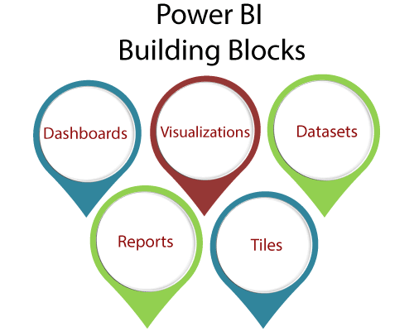
Power BI provides different types of visuals, such as:
- Bar charts
- Column charts
- Line graphs
- Pie charts
- Maps
- Tables and cards
Example:
If a company wants to see its monthly sales, a line chart can show whether sales are increasing or decreasing each month.
In simple words:
👉 Visualization = Graphical representation of data.

2. Reports
A report is a collection of one or more pages containing different visualizations. It combines charts, tables, text, and other graphics to present information in an organized way.
A report can contain multiple pages, with each page focusing on a different aspect of the data.
Example:
A company's Sales Report may have:
- Page 1 – Overall Sales
- Page 2 – Sales by State
- Page 3 – Sales by City
- Page 4 – Profit by Product
- Page 5 – Sales Performance
In simple words:
👉 Report = A collection of related visualizations arranged on one or more pages.

3. Dashboards
A dashboard provides a single-screen view of the most important information. It brings together important visualizations and key numbers so that users can understand the overall situation quickly.
Dashboards are useful for monitoring performance and making decisions.
Example:
A Sales Dashboard might show:
- Total Sales
- Total Profit
- Number of Orders
- Sales by Region
- Monthly Sales
- Best-Selling Products
All these important details can be displayed on one screen.
In simple words:
👉 Dashboard = A single-screen summary of important information.

4. Datasets
A dataset is the collection of data that Power BI uses to create reports and visualizations.
The data can come from different sources, such as:
- Excel files
- SQL Server
- Oracle databases
- Other supported data sources
For example, an Excel file containing Customer Name, Product, Sales, Quantity, and Profit can be imported into Power BI as a source of data.
In simple words:
👉 Dataset = The data used to create reports and visualizations.

5. Tiles
A tile is a single visual displayed on a Power BI dashboard.
For example, if a dashboard contains:
- A pie chart showing sales by category
- A bar chart showing sales by city
- A card showing total sales
Each individual visual is called a tile.

9. Power BI DAX - Complete Reference
DAX Fundamentals
What is DAX?
DAX (Data Analysis Expressions) is a collection of functions, operators, and constants that can be used in a formula or expression to calculate and return one or more values.
DAX Data Types
🔢 NUMERIC
- Integer (Whole numbers)
- Decimal (Fixed & Floating)
- Currency (Fixed with 4 decimals)
- Boolean (TRUE/FALSE)
📝 TEXT
- String (Unicode text)
- Binary Object
📅 DATE/TIME
- Date (YYYY-MM-DD)
- Time (HH:MM:SS)
- DateTime
📊 TABLE
- Table object

DAX Function Categories - Complete List
1. Aggregate Functions
FUNCTION DESCRIPTION
- SUM Adds all numbers in a column
- SUMX Evaluates expression for each row and sums
- AVERAGE Returns arithmetic mean
- AVERAGEX Evaluates expression for each row and averages
- MIN Returns minimum value
- MAX Returns maximum value
- COUNT Counts numbers in column
- COUNTA Counts non-blank values
- PRODUCT Multiplies values in column
Aggregate Function Examples
dax
// Basic Aggregates
- Total Sales = SUM(Sales[Amount])
- Average Order = AVERAGE(Sales[Amount])
- Min Order = MIN(Sales[Amount])
- Max Order = MAX(Sales[Amount])

// Aggregates with Filters
Total Sales Tech = CALCULATE(SUM(Sales[Amount]), Products[Category] = "Technology")
2. Count Functions
FUNCTION DESCRIPTION
- COUNT Counts numbers in a column
- COUNTA Counts non-blank values in a column
- COUNTBLANK Counts blank values in a column
- COUNTROWS Counts rows in a table
- DISTINCTCOUNT Counts unique values in a column
- DISTINCTCOUNT Counts unique non-blank values
Count Function Examples
dax
// Basic Counts
Total Orders = COUNT(Sales[OrderID])
Total Customers = COUNTA(Customers[CustomerID])

3. Date & Time Functions
- FUNCTION DESCRIPTION
- DATE Creates date from year, month, day
- DATEVALUE Converts text to date
- TIME Creates time from hour, minute, second
- TIMEVALUE Converts text to time
- YEAR Extracts year from date
- MONTH Extracts month from date
- DAY Extracts day from date
- HOUR Extracts hour from time
- MINUTE Extracts minute from time
- SECOND Extracts second from time
- NOW Returns current date and time
- TODAY Returns current date
- WEEKDAY Returns day of week
─┴ ─┘
Date Function Examples
dax
// Basic Date Operations
Current Date = TODAY()
Current DateTime = NOW()
Year = YEAR(Sales[OrderDate])

// Date Calculations
Days in Quarter = DATEDIFF(DATE(2024,1,1), DATE(2024,3,31), DAY)
Week Number = WEEKNUM(Sales[OrderDate])
Day Name = FORMAT(Sales[OrderDate], "dddd")

4. Text Functions
FUNCTION DESCRIPTION
- CONCATENATE Joins two text strings
- LEFT Extracts leftmost characters
- RIGHT Extracts rightmost characters
- MID Extracts from middle
- LEN Returns length of text
- UPPER Converts to uppercase
- LOWER Converts to lowercase
Text Function Examples
dax
// Basic Text Operations
Full Name = CONCATENATE(Customers[FirstName], " ", Customers[LastName])
First Initial = LEFT(Customers[FirstName], 1)

// Text Transformation
Upper Name = UPPER(Customers[Name])
Lower Name = LOWER(Customers[Name])

5. Logical Functions
FUNCTION DESCRIPTION
- AND Returns TRUE if all conditions true
- OR Returns TRUE if any condition true
- NOT Reverses logical value
- IF Conditional logic
- IFERROR Handles errors

Logical Function Examples
dax
// Basic IF Statements
Profit = IF(Sales[Revenue] > Sales[Cost], "Profit", "Loss")
Status = IF(Sales[Amount] > 1000, "High", "Low")

// Nested IF
Category =
IF(Sales[Amount] > 10000, "Premium",

9. Mathematical Functions
FUNCTION DESCRIPTION
- ABS Returns absolute value
- CEILING Rounds up to nearest multiple
- FLOOR Rounds down to nearest multiple
- ROUND Rounds to specified decimal
- SQRT Square root
- POWER Raises to power

Some practical implementation of Power Bi practical steps are as follow(Hands-On Scenarios)
This section provides step-by-step practical walk-throughs for common data cleaning operations in Power Query Editor, accompanied by practical enterprise business examples.
Scenario A: Deduplicating Customer Records
Business Goal: Remove redundant transaction rows caused by system duplication, retaining unique customer interactions.
- Open Power Query Editor by clicking 'Transform Data' on the Home tab.
- Select the target column (e.g., 'CustomerID' or 'TransactionID').
- Right-click the column header and select 'Remove Duplicates'.
Practical Example: In an e-commerce order table containing 15,000 logs with multiple duplicate API submissions, applying 'Remove Duplicates' on 'TransactionID' ensures exact accounting figures.
Scenario B: Splitting Full Names into First & Last Name
Business Goal: Separate combined name strings into individual fields for personalized email campaigns.
- Select the 'Customer Name' column in Power Query.
- Navigate to the 'Transform' ribbon tab -> Select 'Split Column' -> Choose 'By Delimiter'.
- Set Delimiter to 'Space' and select 'Left-most delimiter' or 'Each occurrence of the delimiter'.
- Rename the newly generated columns to 'First Name' and 'Last Name'.
Scenario C: Formatting Text Case (Capitalize Each Word)
Business Goal: Standardize inconsistent text entries (e.g., 'john DOE', 'mary jane') into clean Proper Case format.
- Select the text column requiring formatting.
- Go to 'Transform' tab -> Click 'Format' dropdown -> Select 'Capitalize Each Word'.
Scenario D: Replacing Blank/Null Cells with Custom Values
Business Goal: Fill blank or null entries with standard default text to prevent visual reporting errors.
- Select the column containing missing values.
- Go to 'Transform' tab -> Click 'Replace Values'.
- In 'Value To Find', enter: null (or leave empty). In 'Replace With', enter your custom string (e.g., 'Abbas' or 'Unassigned').
Scenario E: Reverting Applied Query Steps ('Delete Until End')
Business Goal: Roll back multiple erroneous query changes without re-importing the data source from scratch.
- Locate the 'Applied Steps' pane on the right side of the Power Query window.
- Identify the step where formatting errors occurred.
- Right-click the step preceding the mistake and select 'Delete Until End'.
- Confirm deletion; all downstream steps are removed, restoring data to its prior state.

